STEP-BY-STEP GUIDE FOR AMBIS PROCESS 5(a) – ‘REPORTING’
- As a beneficiary, log in to your AMBIS account with your username and password.
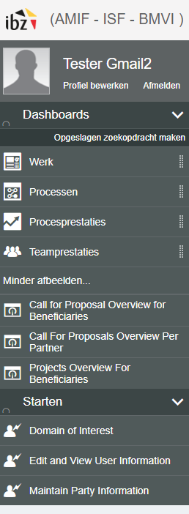
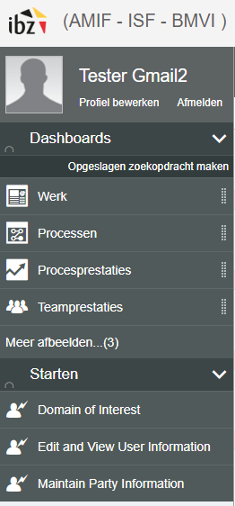
- In the ‘Dashboards’ section (left side of your screen), click on ‘Show more’. Then click on ‘Projects Overview For Beneficiaries’.
- Look for the project in question in the list. Scroll to the right side of the screen until you see all the ‘blue icons’.
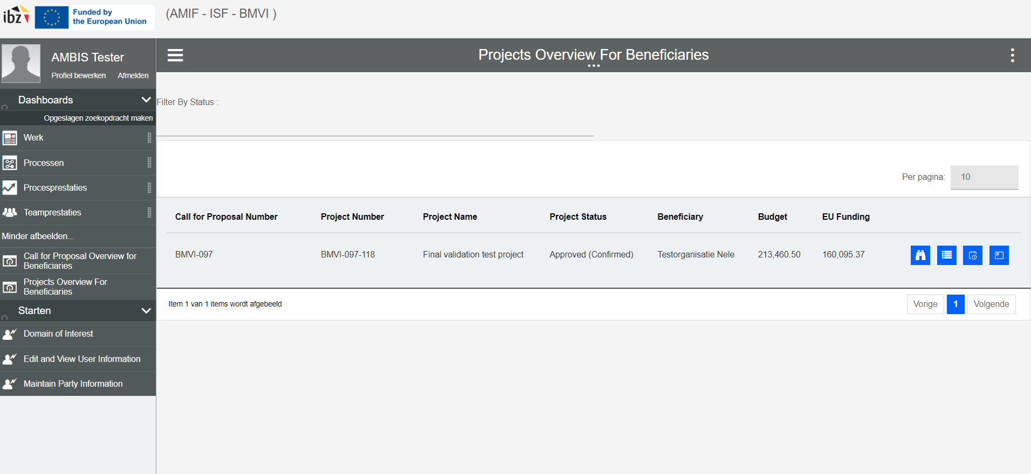
- Select the blue icon titled ‘View project details’.

- After clicking on this, you will see the project dashboard.
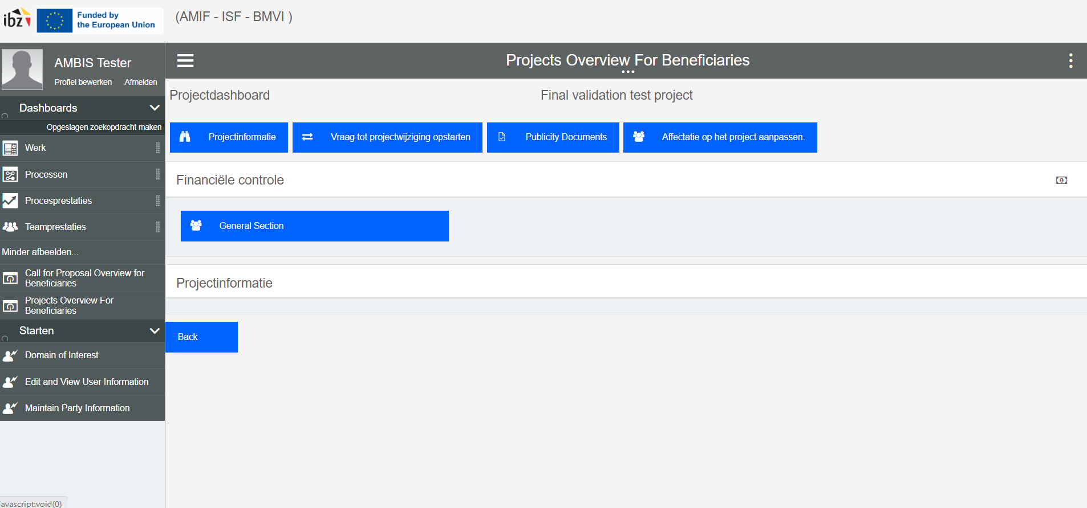
- Click on ‘General Section’.
You will be redirected to a new screen, which looks as follows:
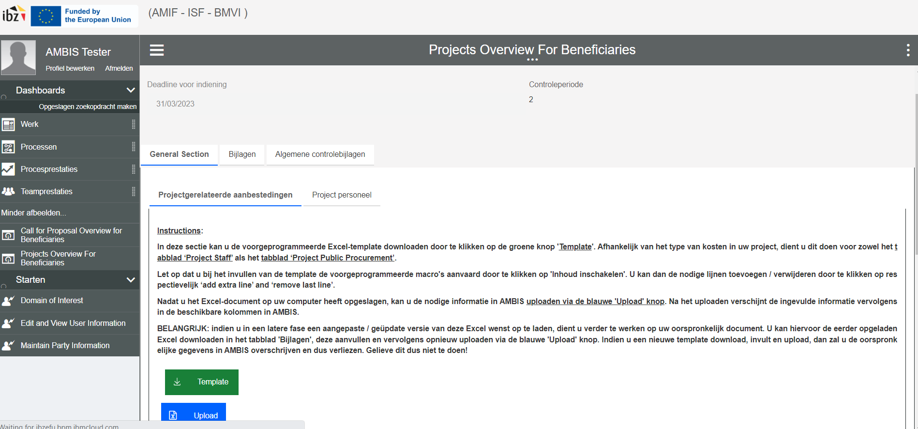
In the ‘General Section’, you will not be requested, nor will you be able to do any financial reporting of concrete costs! This section is solely designed in order to capture the necessary background information regarding your financial reporting.
Financial reporting of concrete / actual costs made during the project will take place through a specific task in your AMBIS work list. This task will be automatically launched after every (6-monthly) reporting period, and will each time run / be open for a period of 1 month:
- Reporting period January – June: task available from 01/07 until 31/07;
- Reporting period July – December: task available from 01/01 until 31/01;
In this step, you will see a tab ‘General Section’, a tab ‘Attachments’ and a tab ‘Common Control Attachments / Algemene controlebijlagen’.
As a beneficiary, you will be able to consult this ‘General Section’ at any moment during the duration of your project. You will also be able to freely adapt, update and upload any additional information here during the entire duration of the project.
In the tab ‘General Section’, you will see a sub-tab ‘Project Staff’ and a sub-tab ‘Project Public Procurement’.
In each sub-tab, you have the option to download the pre-programmed Excel-template by clicking on the green ‘Template’ button. After downloading the template, you are then expected to fill out the document by adding all required information. Before filling in the document, please read the ‘Instructions’ tab of the Excel template. It is also important to activate the pre-programmed macro’s by clicking on ‘Enable content’ / ‘Inhoud inschakelen’.
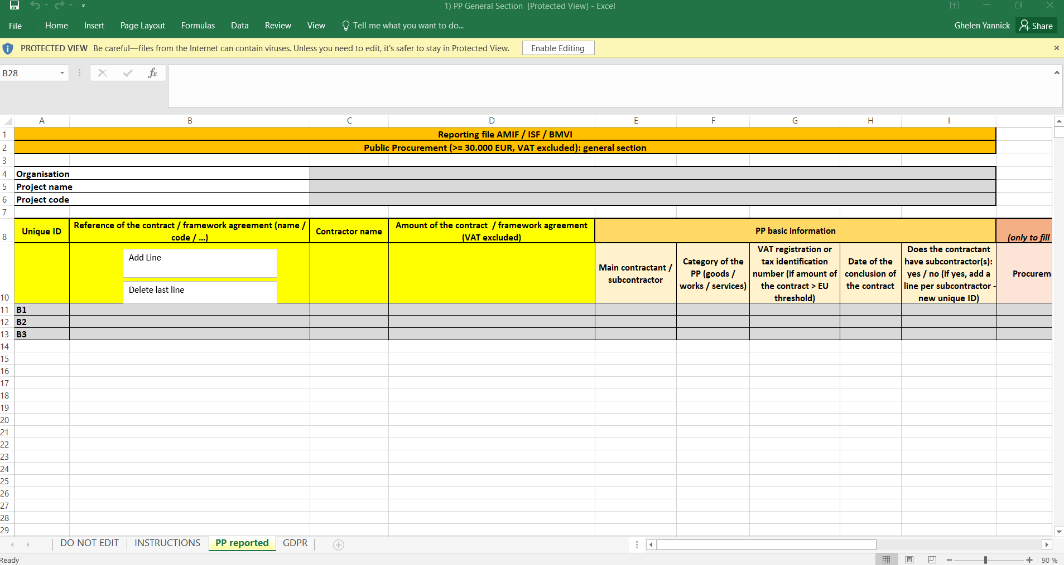
You can add lines by clicking on respectively the ‘add extra line’ and ‘remove last line’ buttons. Please make sure to use these buttons when adding / deleting lines, since lines added manually will not be reflected when parsing the Excel in the AMBIS-system.
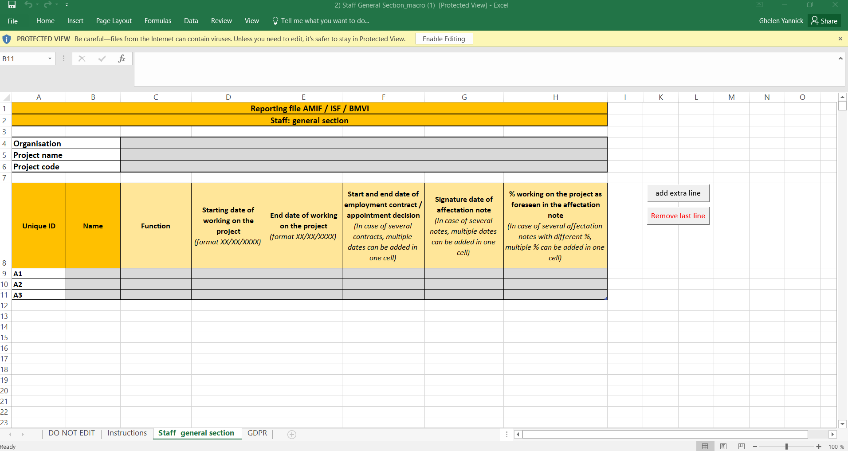
After saving the Excel-document on your computer and completing it, you are required to upload it in the AMBIS-system via the blue ‘Upload’ button. After uploading, you will see a (quick) message mentioning that the ‘Excel was successfully parsed’, after which the uploaded information will appear in the respective columns below on your AMBIS-screen.
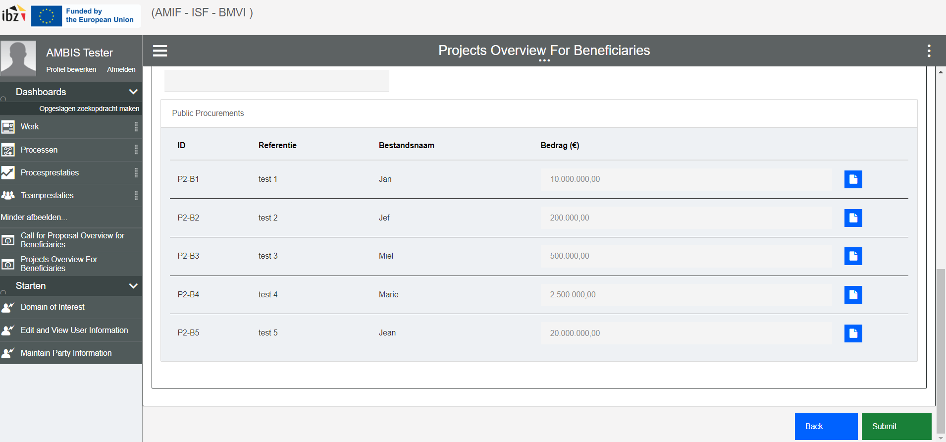
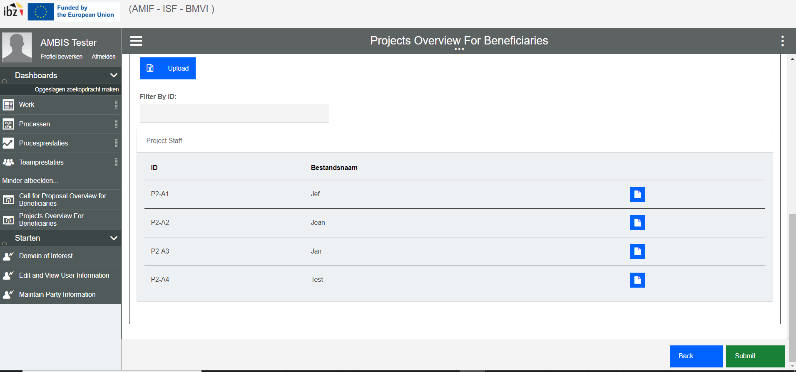
After the information was successfully parsed in the AMBIS-system, you will notice blue icons have appeared on the right side of every line. Here you are expected to upload a set of required background documents:
- In the sub-tab ‘Project staff’, you are requested to upload for every staff member the following documents:
  - Employment contract (or equivalent);
  - Affectation note (assigning the person in question to the project in question);
  - Description of tasks;
  - Salary / payment slip (of the 1st month on the project).
  - You also have the option to add ‘other’ relevant documents, if needed.
- In the sub-tab ‘Project Public Procurement’, you are requested to upload for every public procurement >= 30.000 EUR (TVA excluded) the following attachments:
  - Book of specifications (in all available languages) / lastenboek (in alle beschikbare talen) / cahier des charges (dans toutes les langues disponibles);
  - Award report / gunningsverslag / rapport d’attribution;
  - Motivated award decision / gemotiveerde gunningsbeslissing / décision motivée d'attribution;
  - Notification letters to all of the subscribers / notificatiebrieven gericht aan alle inschrijvers / lettres de notification à tous les soumissionnaires;
  - Composition of the tender evaluation committee, including declarations of absence of conflict of interest / samenstelling van het evaluatiecomité, met inbegrip van de verklaringen omtrent de afwezigheid van belangenconflicten / composition du comité d'évaluation du marché public, y compris les déclarations d'absence de conflit d'intérêt;
  - UBO (Ultimate Beneficial Owners) fiche (if amount of the contract > EU threshold) / UBO fiche (finale begunstigde) / fiche UBO (bénéficiaires effectifs) (si montant du contrat > seuil UE);
  - In case of a public authority, additional documents are required:
    - all Finance Inspector advices linked to the PP (concerning both the launch as well as the awarding of the PP) / alle adviezen IF gelinkt aan de openbare aanbesteding (betreffende zowel de lancering als de toekenning v/d markt) / tous les avis IF liés au marché public (concernant le lancement et l'attribution du marché)
    - advice of the Minister of Budget / advies van de Minister van Begroting / l’avis du Ministre de Budget (if applicable);
    - all documents related to the approval of the Council of Ministers (notes, notification decision, etc.) / alle relevante documenten (nota's, notificatie, etc.) i.v.m. de goedkeuring door de Ministerraad / tous les documents utiles (notes, décision de notification, etc.) concernant l’accord du Conseil des Ministres (if applicable).
  - In case of SMALS-consultancy, other specific document types are required to be uploaded (i.e. ‘Bijzondere Samenwerkingsmodaliteiten’ (BSM’s) and ‘infofiches / fiches d’info / activatiefiches / fiches d’activation’).
In the tab ‘Attachments’ / ‘Bijlagen’, you are able to consult the uploaded Excel-reporting files.
IMPORTANT: if you wish to upload a modified / updated version of this Excel at a later stage, you will need to continue working on your original document. In order to do this, you can download the previously uploaded Excel via the 'Attachments' tab, complete it further and then upload it again by using the blue 'Upload' button.
If you download, complete and upload a new template, you will overwrite the original data in AMBIS and thus lose the previously uploaded data! Do not do this!
In the tab ‘Common Control Attachments’, you are not expected / it will not be possible for you to upload any documents. This is an internal tab in which the Managing Authority will place all information with regard to costs / elements under discussion which have to be taken into consideration from one reporting period to the next.
When ready, you can then choose to either ‘Submit’ or go ‘Back’. In order to save your changes, you should always click on ‘Submit’.
After clicking on ‘Submit’, you will see the following pop-up message:
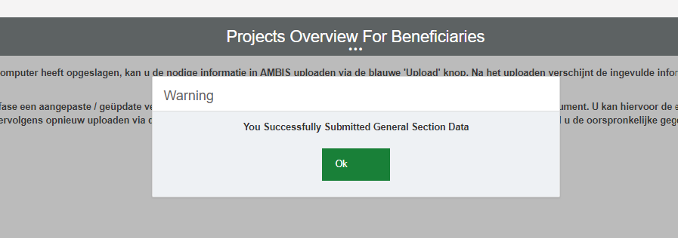
After clicking on ‘OK’, you can go back to your work list by clicking on the ‘Back’ button or via the ‘Dashboards’ section on the left side of your AMBIS screen.
- As mentioned before, financial reporting of concrete / actual costs made during the project will take place through a specific task in your AMBIS work list. This task will be automatically launched after the end of every (6-monthly) reporting period, and will each time be open for a period of 1 month:
- Reporting period January – June: task available from 01/07 until 31/07;
- Reporting period July – December: task available from 01/01 until 31/01.

- In the account of the beneficiary, a new task named ‘Control and Monitoring – Upload Project Report’ will have appeared in the ‘Work’ overview. Depending on the type of reporting (intermediary vs final), this task will always mention the reporting period and/or the word ‘final’ (indicating that it involves a final report).
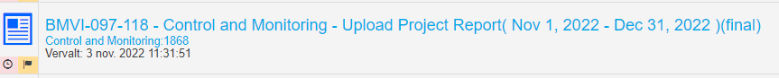
Select this task by clicking on it. A pop-up message will appear: then click on ‘Claim task’. This task will now be assigned to you.
You will be redirected to a new screen, which looks as follows:
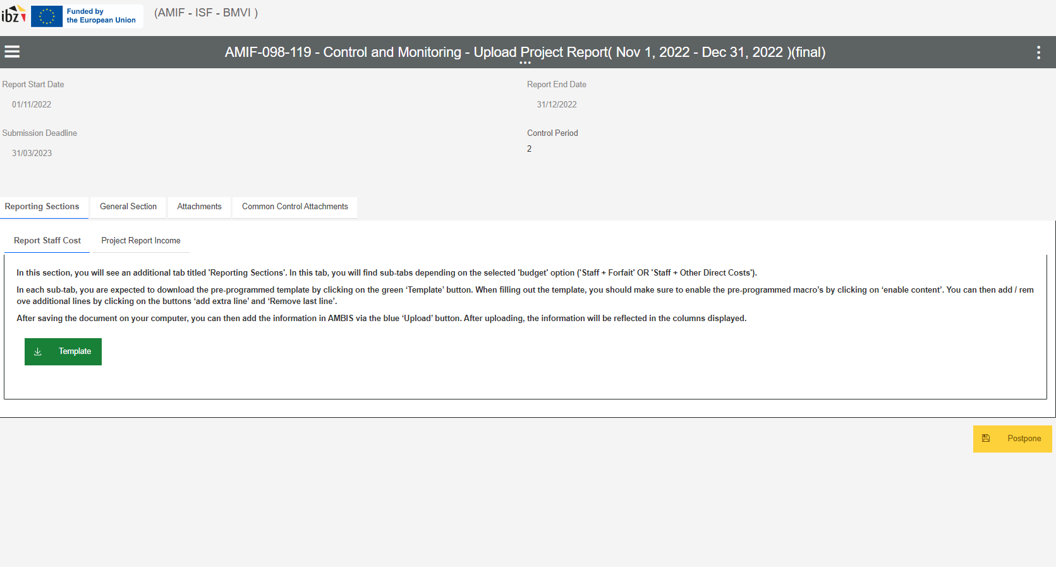
In this section, you will see an additional tab titled 'Reporting Sections'.
In the tab ‘Reporting Sections’, you will see different sub-tabs, depending on the type of costs in your project. In case you have opted for a budget with only ‘Staff costs’ and a lump sum (i.e. ‘forfait’), you will only see a sub-tab ‘Report Staff Costs’. In case you have opted for a budget with ‘Staff costs’ and/or ‘Other direct costs’ with ‘Indirect costs’, you will see a sub-tab ‘Report Staff Costs’ as well as a sub-tab ‘Project Report Other Direct Costs’. (Only) in case of a final report, you will also see a sub-tab ‘Project Report Income’.
At every point in time, you will have the option to ‘Postpone’ the task in question, thereby returning to your work list.
IMPORTANT: The specific ‘reporting’ task does not have a ‘Submit’ button. This is mainly due to practical concerns about early / faulty submission of financial reports. Instead, the task in question will remain open in your worklist, until the above-mentioned 1 month period has expired, i.e.:
- Reporting period January – June: task available from 01/07 until 31/07;
- Reporting period July – December: task available from 01/01 until 31/01.
After this time, the task will be automatically submitted in the AMBIS-system, and there will be no more changes possible. Please make sure to undertake the necessary steps in AMBIS and introduce the required data / information before this automatic submission!
In each sub-tab, you have the option to download the pre-programmed Excel-template by clicking on the green ‘Template’ button. After downloading the template, you are then expected to fill out the document by adding all required information. Before filling in the document, please read the ‘Instructions’ tab of the Excel template. It is also important to activate the pre-programmed macro’s by clicking on ‘Enable content’ / ‘Inhoud inschakelen’.
- The ‘Staff Costs’ reporting template looks as follows:
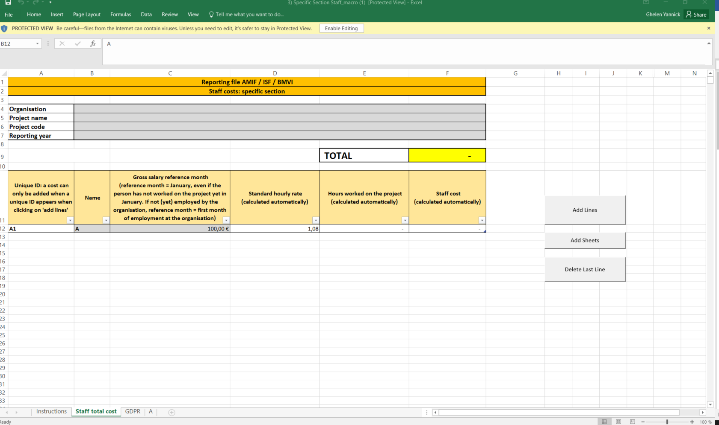
You can add /remove lines by clicking on respectively the ‘Add lines’ and ‘Delete Last Line’ buttons. Please make sure to use these buttons when adding / deleting lines, since lines added manually will not be reflected when parsing the Excel in the AMBIS-system. You can also manually add time registration sheets for every staff member on the project once their names have been filled out, and this by clicking on the ‘Add Sheets’ button.
After saving the Excel-document on your computer and completing it, you are required to upload it in the AMBIS-system. For the ‘Staff Costs’, you will have to upload the filled-in reporting template manually via the ‘Attachments’ section.
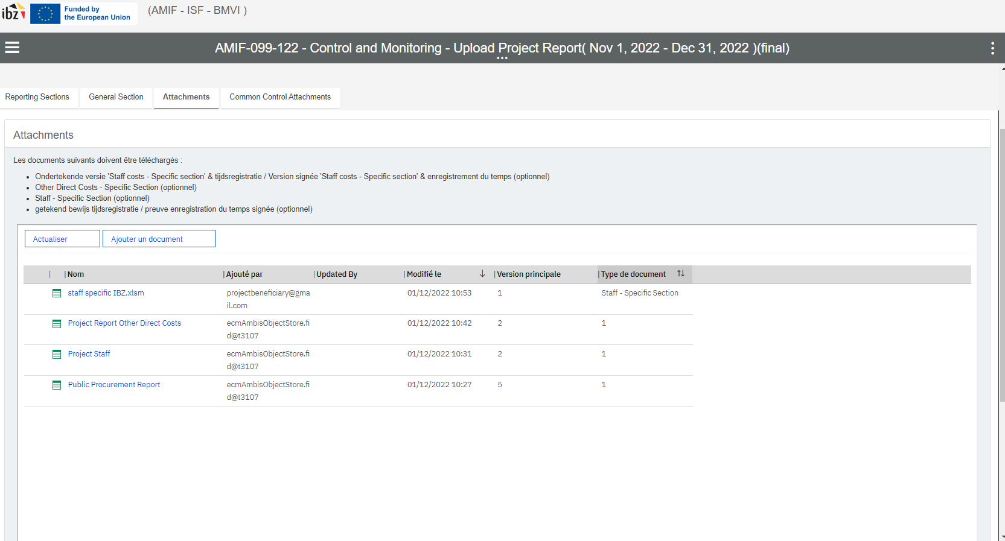
- The ‘Other Direct Costs’ reporting template looks as follows:
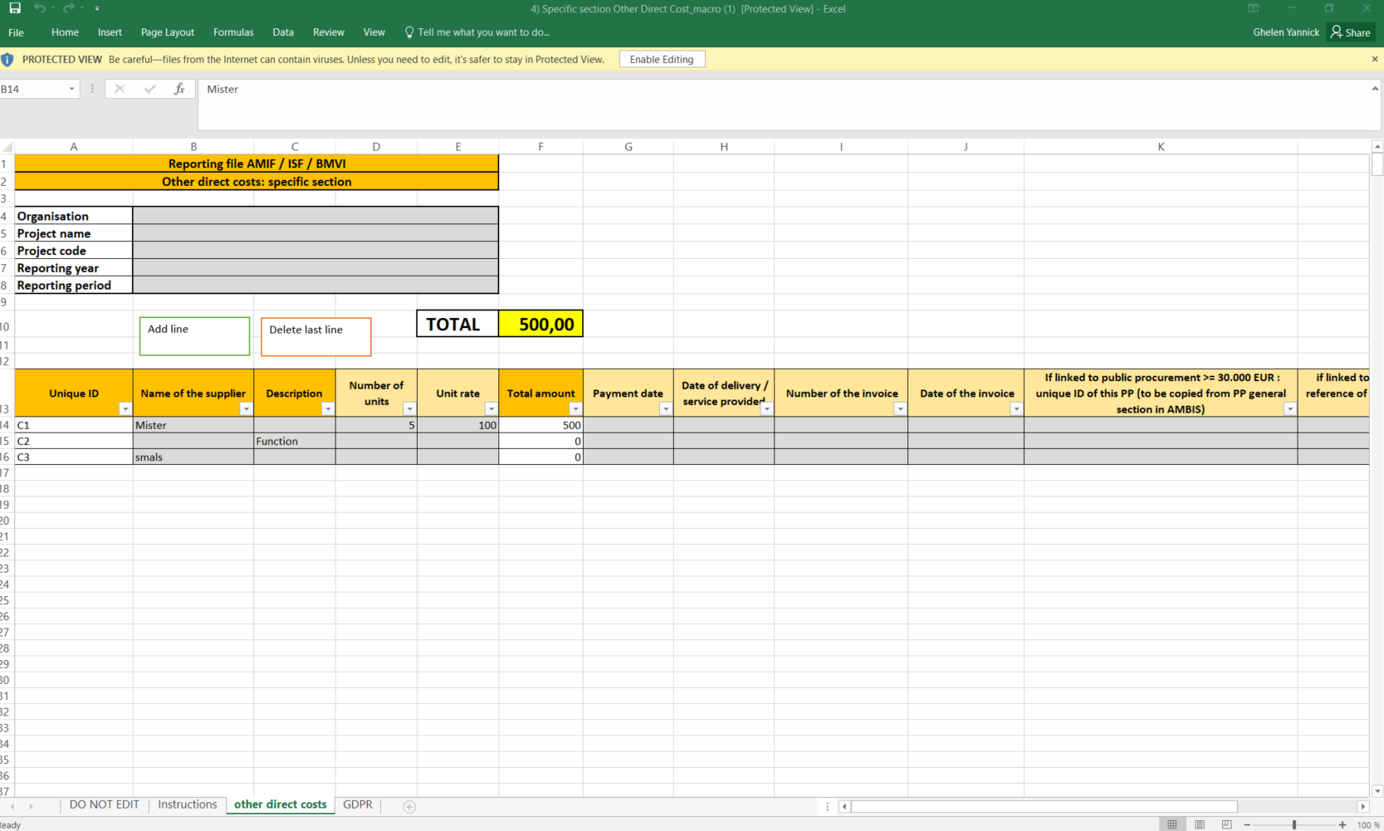In this Excel document, you are expected to report in a detailed manner the costs you have made during this specific reporting period. Please be advised that there are certain minimum amounts applicable (as a general rule: € 1000,00). For details on this, check the applicable eligibility rules for your project.
You can add /remove lines by clicking on respectively the ‘Add line’ and ‘Delete last line’ buttons. Please make sure to use these buttons when adding / deleting lines, since lines added manually will not be reflected when parsing the Excel in the AMBIS-system.
After saving the Excel-document on your computer and completing it, you are required to upload it in the AMBIS-system via the blue ‘Upload’ button. After uploading, you will see a (quick) message mentioning that the ‘Excel was successfully parsed’, after which the uploaded information will appear in the respective columns below on your AMBIS-screen.
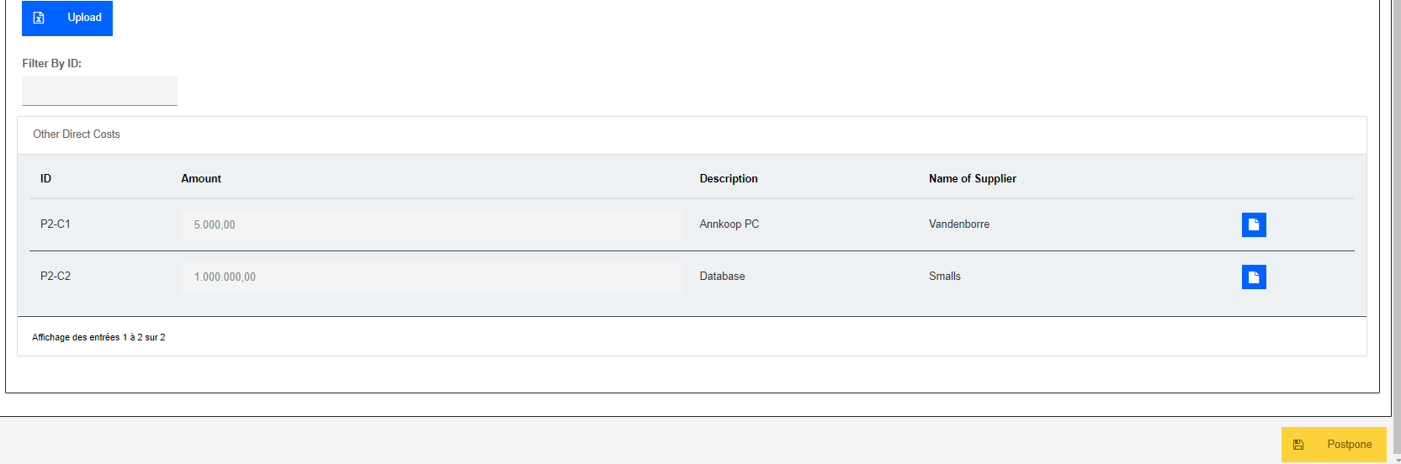
After the information was successfully parsed in the AMBIS-system, you will notice blue icons have appeared on the right side of every line. Here you are expected to upload for every reported cost a set of required background documents:
- Related invoice;
- Link with the project (if not clear / evident from the invoice itself);
- Proof of market consultation;
- Other relevant documentation.
IMPORTANT: if you wish to upload a modified / updated version of this Excel at a later stage, you will need to continue working on your original document. In order to do this, you can download the previously uploaded Excel via the 'Attachments' tab, complete it and then upload it again using the blue 'Upload' button.
If you download, complete and upload a new template, you will overwrite the original data in AMBIS and thus lose previous data! Do not do this!
At every point in time, you have the option to ‘Postpone’ the task in question and return to your work list.
- The ‘Income’ reporting template looks as follows:
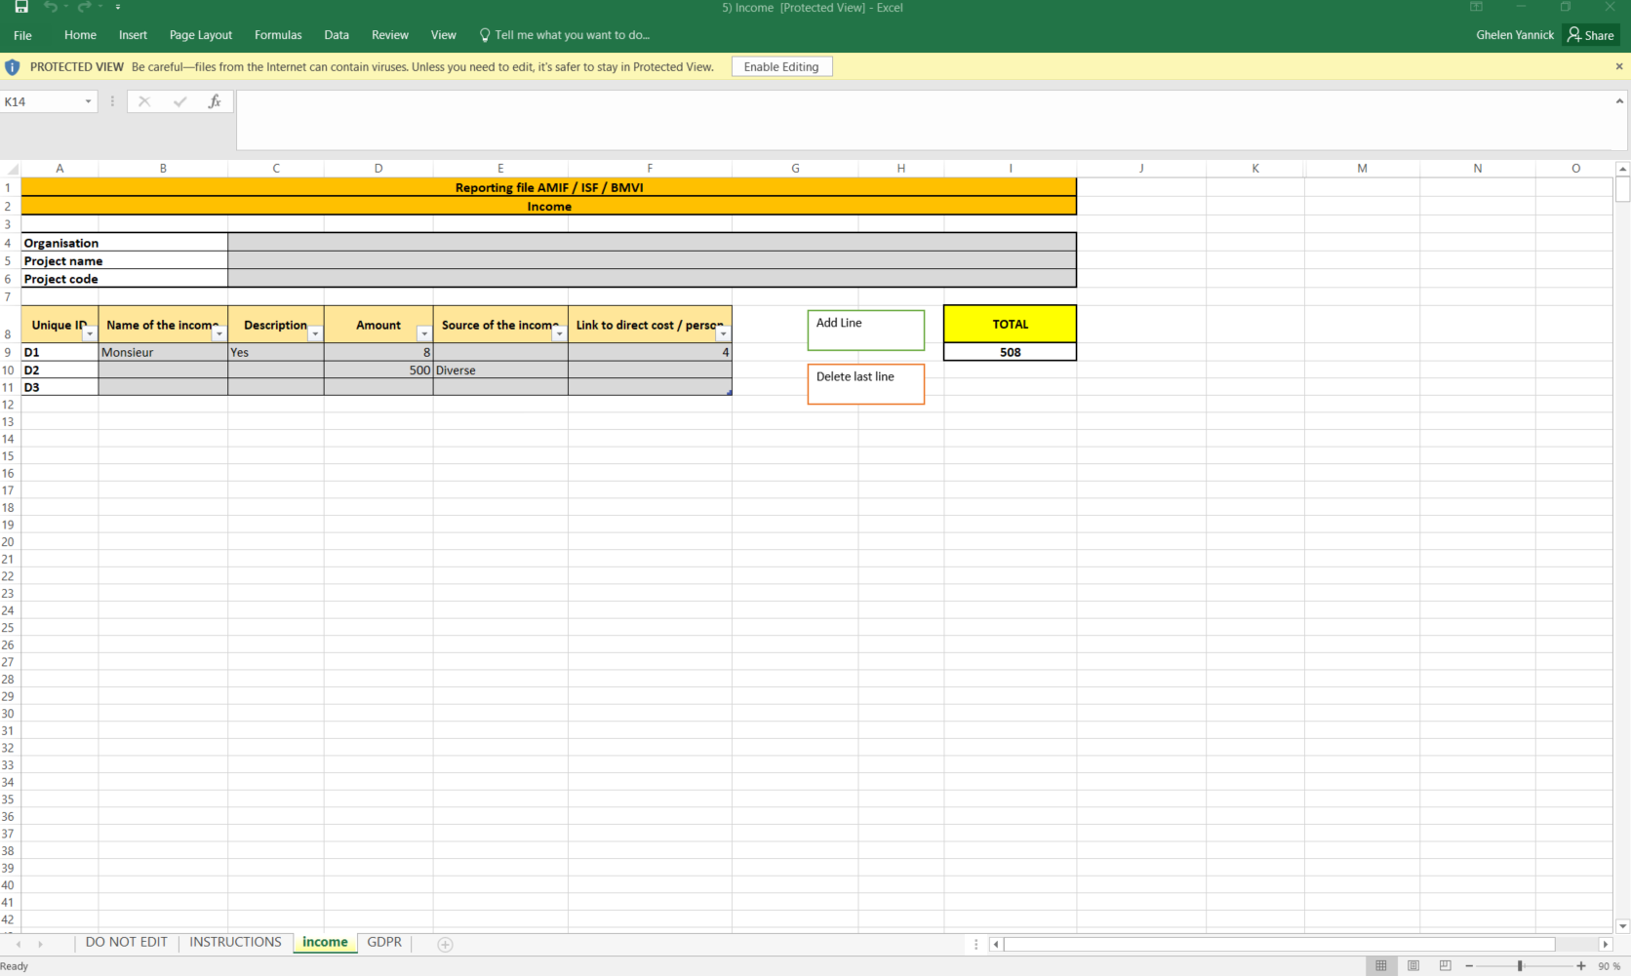
You can add /remove lines by clicking on respectively the ‘Add line’ and ‘Delete last line’ buttons. Please make sure to use these buttons when adding / deleting lines, since lines added manually will not be reflected when parsing the Excel in the AMBIS-system.
After saving the Excel-document on your computer and completing it, you are required to upload it in the AMBIS-system via the blue ‘Upload’ button. After uploading, you will see a (quick) message mentioning that the ‘Excel was successfully parsed’, after which the uploaded information will appear in the respective columns below on your AMBIS-screen.
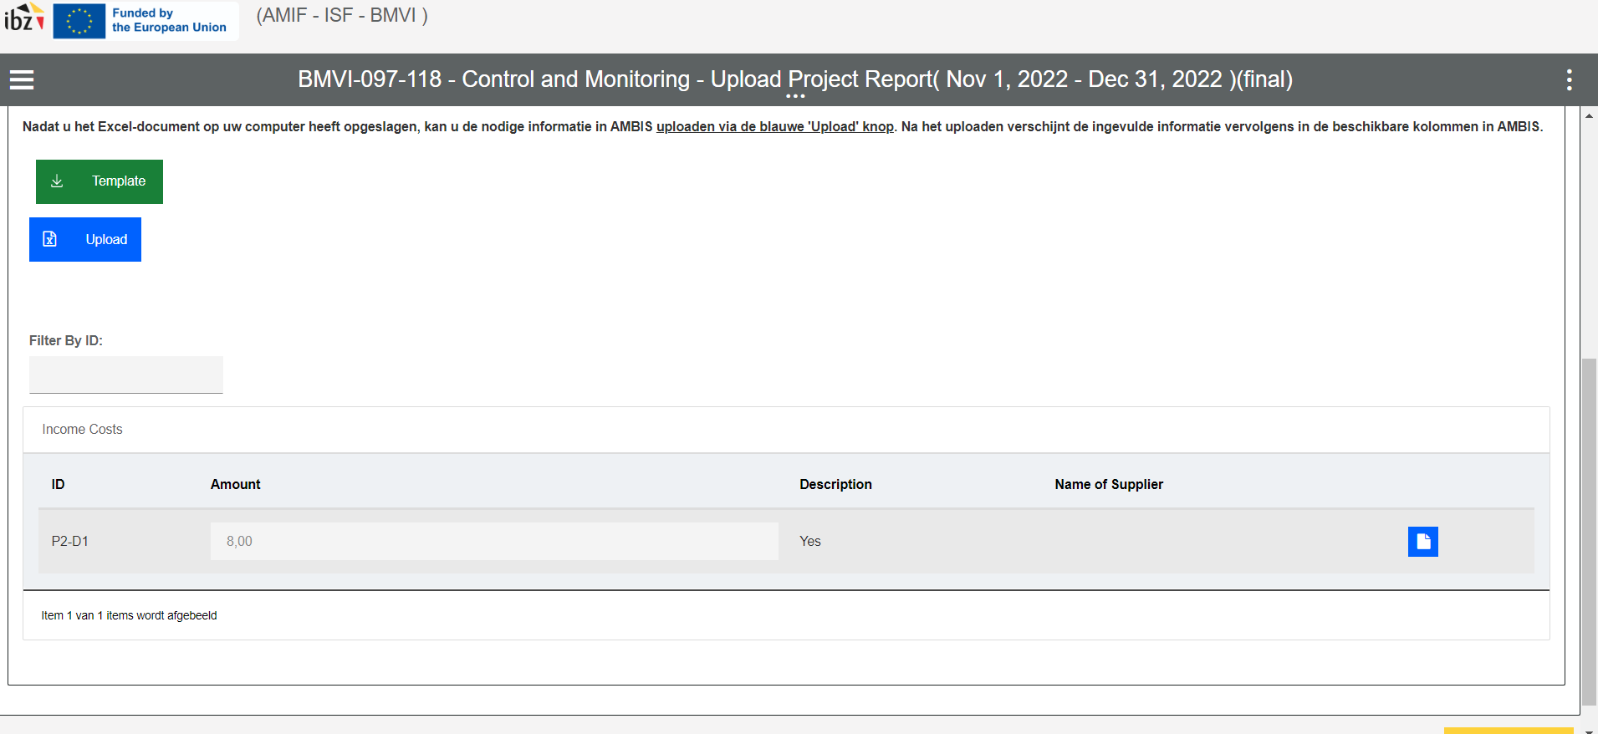After the information was successfully parsed in the AMBIS-system, you will notice blue icons have appeared on the right side of every line. Here you are expected to upload for every reported income the necessary elements of proof.
In the tab ‘Attachments’ / ‘Bijlagen’, you are able to consult the uploaded Excel-reporting files.
In the tab ‘Common Control Attachments’, you are not expected / it will not be possible for you to upload any documents. This is an internal tab in which the Managing Authority will place all information with regard to costs / elements under discussion which have to be taken into consideration from one reporting period to the next.
At every point in time, you have the option to ‘Postpone’ the task in question and return to your work list.
In addition, as mentioned before, this specific ‘reporting’ task does not have a ‘Submit’ button. Instead, the task will automatically close and submit after the one-month reporting time has passed!
- In the account of the beneficiary, a new task named ‘Content and Indicators Control – Fill in indicators’ will have appeared in the ‘Work’ overview. Again, depending on the type of reporting (intermediary vs final), this task will always mention the reporting period and/or the word ‘final’ (indicating that it involves a final report).
Select this task by clicking on it. A pop-up message will appear: then click on ‘Claim task’. This task will now be assigned to you.
You will be redirected to a new screen, which looks as follows:
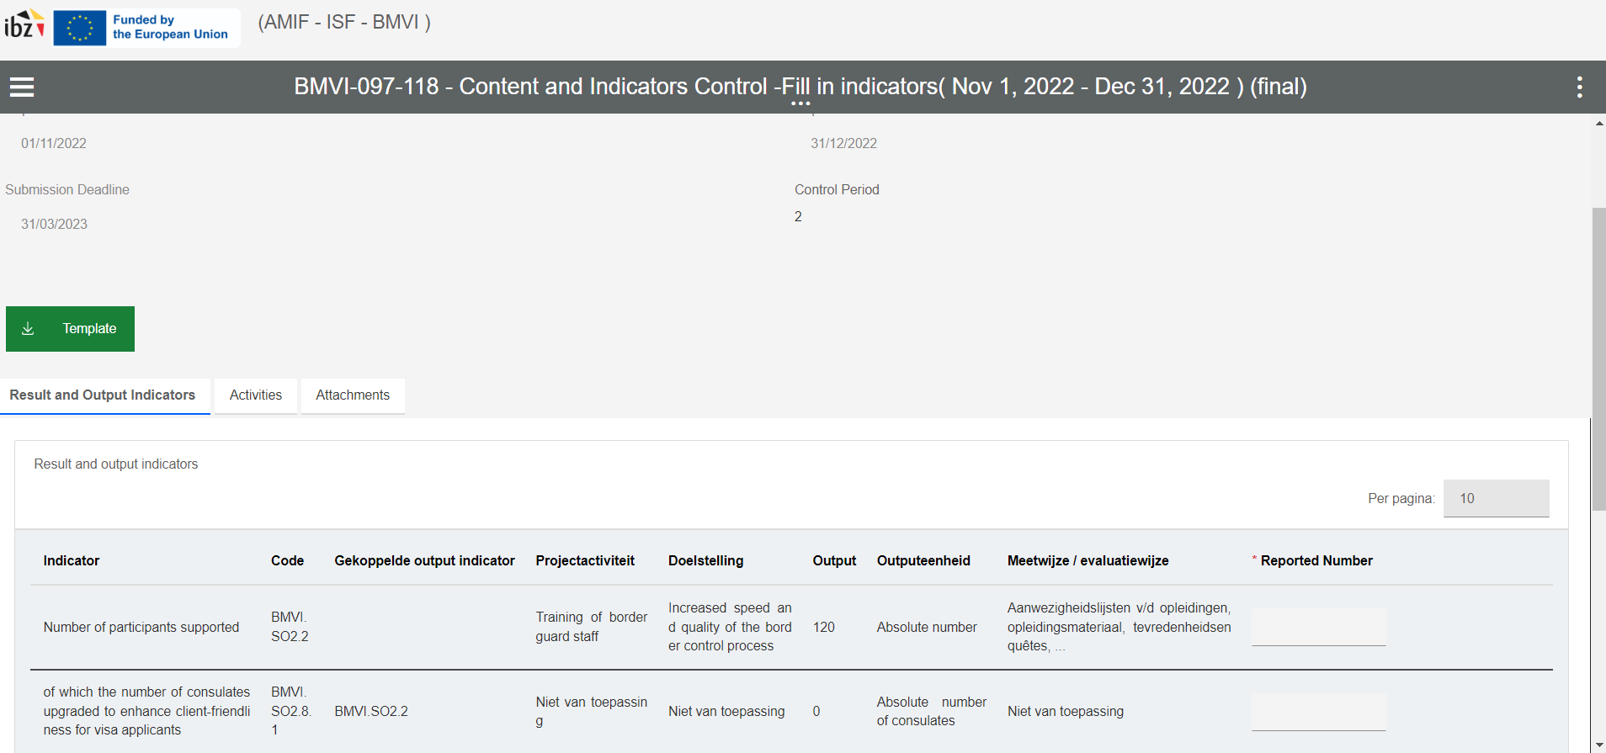
In this section, you will notice the following tabs:
- a tab ‘Result and Output Indicators’;
- a tab ‘Activities’, and
- a tab ‘Attachments’.
In the tab ‘Result and Output Indicators’, you will see an overview of all the output- and result indicators as selected by the beneficiary during the project proposal submission phase. In this step, you are required to add the relevant numbers per output / result indicator, and this in the column ‘Reported Number’.
In the tab ‘Activities’, you will see an overview of all project-specific indicators as selected by the beneficiary during the project proposal submission phase. In this step, you are required to add the relevant numbers per ‘activity’, and this in the column ‘Reported Number’.
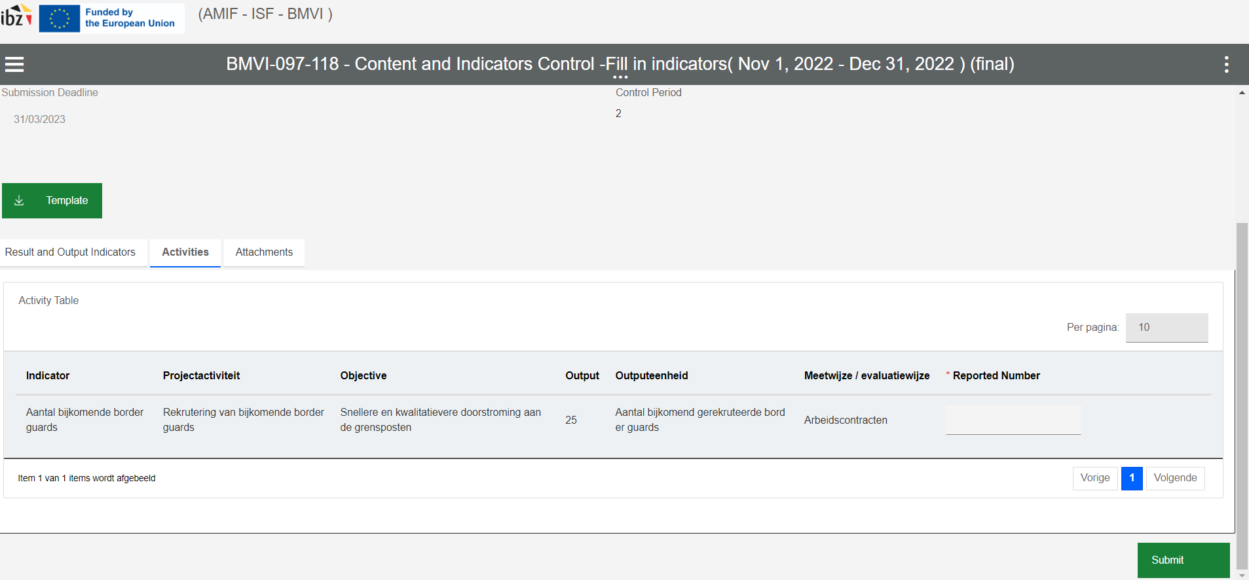
In the tab ‘Attachments’, you are able to consult the uploaded documents.
In this step, you are also required to upload a narrative report (either an intermediary narrative report or a final narrative report, depending on the type of reporting (as mentioned in the task name). You can do this by downloading the pre-programmed Word-template by clicking on the green ‘Template’ button. You will then see both the template for the intermediary narrative report as well as the template for the final narrative report. Both are clearly labelled. Please select the correct reporting template and start filling out the document by adding all required information.
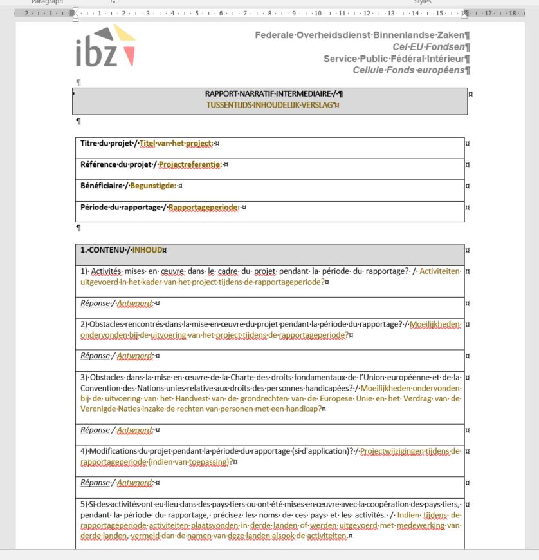
If certain questions are not relevant / not applicable in the context of your project, you are free to simply mention this in your answer.
After saving the Word-document on your laptop, you are required to upload this information in the AMBIS-system. For the ‘narrative report’, you will have to upload the filled-in template manually via the ‘Attachments’ section.
When you have finished with the task, make sure to click on ‘Submit’ in order to save your changes. After clicking on ‘Submit’, you will be redirected to your AMBIS home screen.

